BCA
VI SEMESTER
MOBILE APPLICATION DEVELOPMENT LAB
Total Teaching Hours: 20 Hours/Week: 4
Max Marks: 40 Credits: 4
1. Develop an application that uses GUI components, Font and Colors
2. Develop an application that uses Layout Managers and event listeners.
3. Develop a native calculator application.
4. Write an application that draws basic graphical primitives on the screen.
5. Develop an application that makes use of database.
6. Implement an application that implements Multithreading
7. Develop a native application that uses GPS location information.
8. Implement an application that writes data to the SD card.
9. Implement an application that creates an alert upon receiving a message.
10. Write a mobile application that creates alarm clock

- Develop an application that uses GUI components, Font and Colors.
Algorithm:
- Create a New Android Project
  - Click New in the toolbar.
  - In the window that appears, open the Android folder, select Android Application Project, and click next.
  - Provide the application name and the project name and then finally give the desired package name.
  - Choose a launcher icon for your application and then select Blank Activity and then click Next
  - Provide the desired Activity name for your project and then click Finish.
- Create a New AVD (Android Virtual Device):
  - Click Android Virtual Device Manager from the toolbar.
  - In the Android Virtual Device Manager panel, click New.
  - Fill in the details for the AVD. Give it a name, a platform target, an SD card size, and a skin (HVGA is default).
  - Click Create AVD and Select the new AVD from the Android Virtual Device Manager and click Start
- Design the graphical layout with a text view and two command buttons.
- Run the application.
- On pressing the change color button, color of the text gets changed.
- On pressing the change font size button, the size of the font gets altered.
- Close the Android project.

MainActivity.java
package com.example.mobileapplicationbca;
import androidx.appcompat.app.AppCompatActivity;
import android.os.Bundle;
import android.app.Activity;
import android.graphics.Typeface;
import android.graphics.Color;
import android.view.View;
import android.widget.Button;
import android.widget.TextView;

public class MainActivity extends AppCompatActivity {
float font = 24;
int i = 1;
protected void onCreate(Bundle savedInstanceState) {
super.onCreate(savedInstanceState);
setContentView(R.layout.activity_main);
final TextView t1 = (TextView)findViewById(R.id.textView1);
Button b1 = (Button)findViewById(R.id.button1);
b1.setOnClickListener(new View.OnClickListener(){
public void onClick(View view) {
t1.setTextSize(font);
font = font+4;
if(font==40)
font = 20;
}});
Button b2 = (Button)findViewById(R.id.button2);
b2.setOnClickListener(new View.OnClickListener(){
public void onClick(View view) {
switch(i)
{
case 1:
t1.setTextColor(Color.parseColor("#0000FF"));
break;
case 2:
t1.setTextColor(Color.parseColor("#00FF00"));
break;
case 3:
t1.setTextColor(Color.parseColor("#FF0000"));
break;
case 4:
t1.setTextColor(Color.parseColor("#800000"));
break;
}
i++;
if(i==5)
i = 1;
}
});
}
}

acitivity_main.xml:
<?xml version="1.0" encoding="utf-8"?>
<LinearLayout xmlns:android="http://schemas.android.com/apk/res/android"
android:layout_width="match_parent"
android:layout_height="match_parent"
android:orientation="vertical">
<TextView
android:id="@+id/textView1"
android:layout_width="match_parent"
android:layout_height="wrap_content"
android:layout_margin="20sp"
android:gravity="center"
android:text="@string/welcome"
android:textSize="20sp"
android:textStyle="bold" />
<Button
android:id="@+id/button1"
android:layout_width="match_parent"
android:layout_height="wrap_content"
android:layout_margin="20sp"
android:gravity="center"
android:text="@string/change_font_size"
android:backgroundTint="#3F51B5"/>
<Button
android:id="@+id/button2"
android:layout_width="match_parent"
android:layout_height="wrap_content"
android:gravity="center"
android:layout_margin="20sp"
android:text="@string/change_color"
android:backgroundTint="#3F51B5"/>
</LinearLayout>
Output:
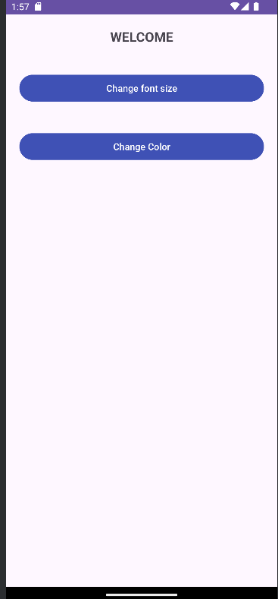

2.Develop an application that uses Layout Managers and event Listeners.
Alogorithm:
- Create a New Android Project:
  - Click New in the toolbar.
  - In the window that appears, open the Android folder, select Android Application Project, and click next.
  - Provide the application name and the project name and then finally give the desired package name.
  - Choose a launcher icon for your application and then select Blank Activity and then click Next
  - Provide the desired Activity name for your project and then click Finish
- Create a New AVD (Android Virtual Device):
  - click Android Virtual Device Manager from the toolbar.
  - In the Android Virtual Device Manager panel, click New.
  - Fill in the details for the AVD. Give it a name, a platform target, an SD card size, and a skin (HVGA is default).
  - Click Create AVD and Select the new AVD from the Android Virtual Device Manager and click Start.
- Design the graphical layout with buttons, edit text and text view.
- Run the application.
- Provide the required inputs to perform the desired arithmetic operation.
- Display the result.
- Close the Android project.

MainActivity.java:
package com.example.pgm2;
import androidx.appcompat.app.AppCompatActivity;
import android.os.Bundle;
import android.app.Activity;
import android.view.View;
import android.view.View.OnClickListener;
import android.widget.Button;
import android.widget.EditText;
import android.widget.Toast;
public class MainActivity extends AppCompatActivity {
EditText txtData1,txtData2;
float num1,num2,result1,result2;
@Override
protected void onCreate(Bundle savedInstanceState) {
super.onCreate(savedInstanceState);
setContentView(R.layout.activity_main);
Button add = (Button)findViewById(R.id.button1);
add.setOnClickListener(new OnClickListener(){
public void onClick(View v){
try
{
txtData1 = (EditText)findViewById(R.id.editText1);
txtData2 = (EditText)findViewById(R.id.editText2);
num1 = Float.parseFloat(txtData1.getText().toString());
num2 = Float.parseFloat(txtData2.getText().toString());
result1 = num1+num2;
Toast.makeText(getBaseContext(),"ANSWER:"+result1,Toast.LENGTH_SHORT).show();
}
catch(Exception e)
{
Toast.makeText(getBaseContext(),e.getMessage(),Toast.LENGTH_SHORT).show();
}
}
});
Button sub = (Button)findViewById(R.id.button3);
sub.setOnClickListener(new OnClickListener(){
public void onClick(View v)
{
try
{
txtData1 = (EditText)findViewById(R.id.editText1);
txtData2 = (EditText)findViewById(R.id.editText2);
num1 = Float.parseFloat(txtData1.getText().toString());
num2 = Float.parseFloat(txtData2.getText().toString());
result2 = num1-num2; Toast.makeText(getBaseContext(),"ANSWER:"+result2,Toast.LENGTH_SHORT).show();
}
catch(Exception e)
{
Toast.makeText(getBaseContext(),e.getMessage(),Toast.LENGTH_SHORT).show();
}
}
});
Button clear = (Button)findViewById(R.id.button2);
clear.setOnClickListener(new OnClickListener() {
public void onClick(View v)
{
try
{
txtData1.setText("");
txtData2.setText("");
}
catch(Exception e)
{
Toast.makeText(getBaseContext(),e.getMessage(),Toast.LENGTH_SHORT).show();
}
}
});
}
}
acitivity_main.xml:
<?xml version="1.0" encoding="utf-8"?>
<RelativeLayout xmlns:android="http://schemas.android.com/apk/res/android"
xmlns:app="http://schemas.android.com/apk/res-auto"
xmlns:tools="http://schemas.android.com/tools"
android:layout_width="fill_parent"
android:layout_height="fill_parent"
tools:context=".MainActivity"
android:id="@+id/relativeLayout1">
<LinearLayout
android:layout_width="wrap_content"
android:layout_height="wrap_content"
android:id="@+id/linearLayout1"
android:layout_alignParentStart="true"
android:layout_alignParentEnd="true"
android:layout_alignParentTop="true"
android:orientation="horizontal">
<TextView
android:layout_width="wrap_content"
android:layout_height="wrap_content"
android:text="@string/calculation"
android:layout_gravity="center"
android:textSize="20sp">
</TextView>
</LinearLayout>
<LinearLayout
android:id="@+id/linearLayout2"
android:layout_width="wrap_content"
android:layout_height="wrap_content"
android:layout_alignParentStart="true"
android:layout_alignParentEnd="true"
android:layout_below="@+id/linearLayout1">
<TextView
android:layout_width="wrap_content"
android:layout_height="wrap_content"
android:text="@string/enter_first_number" />
<EditText
android:id="@+id/editText1"
android:layout_width="0dp"
android:layout_height="wrap_content"
android:layout_weight="0.20"
android:inputType="number">
</EditText>
</LinearLayout>
<LinearLayout
android:id="@+id/linearLayout3"
android:layout_width="wrap_content" android:layout_height="wrap_content"
android:layout_alignParentStart="true"
android:layout_alignParentEnd="true"
android:layout_below="@+id/linearLayout2">
<TextView
android:layout_width="wrap_content"
android:layout_height="wrap_content"
android:text="@string/enter_no_2" />
<EditText
android:id="@+id/editText2"
android:layout_width="0dp"
android:layout_height="wrap_content"
android:layout_weight="0.20"
android:inputType="number">
</EditText>
</LinearLayout>
<LinearLayout
android:id="@+id/linearLayout4"
android:layout_width="fill_parent"
android:layout_height="wrap_content"
android:layout_alignParentStart="true"
android:layout_alignParentEnd="true"
android:layout_below="@+id/linearLayout3"
android:orientation="horizontal">
<Button
android:id="@+id/button1"
android:layout_width="wrap_content"
android:layout_height="wrap_content"
android:layout_gravity="center"
android:text="Addition"
/>
<Button
android:id="@+id/button3"
android:layout_width="wrap_content"
android:layout_height="wrap_content"
android:layout_gravity="center"
android:text="@string/subtraction" />
<Button
android:id="@+id/button2"
android:layout_width="wrap_content"
android:layout_height="wrap_content"
android:layout_gravity="center"
android:text="@string/clear" />
<View
android:id="@+id/linearLayout5"
android:layout_width="fill_parent"
android:layout_height="2dp"
android:background="#DDFFDD" />
</LinearLayout>
</RelativeLayout>

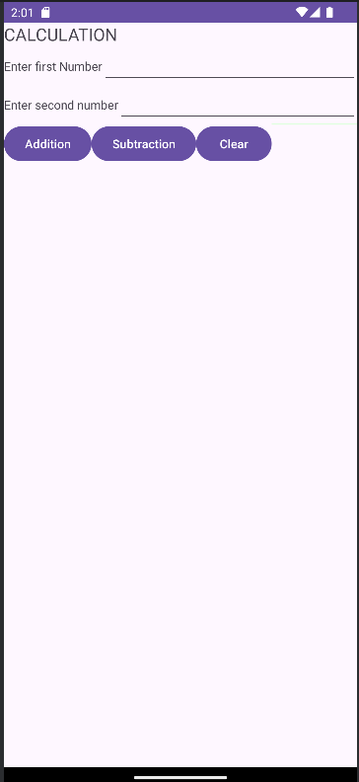

3. Develop a native calculator application
AIM: To develop a calculator android application.
ALGORITHM:
- Create a New Android Project:
  - Click New in the toolbar.
  - In the window that appears, open the Android folder, select Android Application Project, and click next.
  - Provide the application name and the project name and then finally give the desired package name.
  - Choose a launcher icon for your application and then select Blank Activity and then click Next
  - Provide the desired Activity name for your project and then click Finish.
- Create a New AVD (Android Virtual Device):
  - click Android Virtual Device Manager from the toolbar.
  - In the Android Virtual Device Manager panel, click New.
  - Fill in the details for the AVD. Give it a name, a platform target, an SD card size, and a skin (HVGA is default).
  - Click Create AVD and Select the new AVD from the Android Virtual Device Manager and click Start.
- Run the application.
- Provide any two input numbers.
- Choose any arithmetic operations of your choice and the output gets displayed on the display screen of the calculator application.
- Close the Android project.

Program Code:
MainActivity.java:
package com.example.pgm2_nativecalculator;
import androidx.appcompat.app.AppCompatActivity;
import android.annotation.SuppressLint;
import android.os.Bundle;
import android.text.TextUtils;
import android.view.View;
import android.view.View.OnClickListener;
import android.widget.Button;
import android.widget.EditText;
import android.widget.TextView;
public class MainActivity extends AppCompatActivity implements OnClickListener {
//Defining the Views
EditText Num1;
EditText Num2;
Button Add;
Button Sub;
Button Mul;
Button Div;
TextView Result;
Button clearButton;
@Override
protected void onCreate(Bundle savedInstanceState) {
super.onCreate(savedInstanceState);
setContentView(R.layout.activity_main);
//Referring the Views
Num1 = (EditText) findViewById(R.id.editText1);
Num2 = (EditText) findViewById(R.id.editText2);
Add = (Button) findViewById(R.id.Add);
Sub = (Button) findViewById(R.id.Sub);
Mul = (Button) findViewById(R.id.Mul);
Div = (Button) findViewById(R.id.Div);
Result = (TextView) findViewById(R.id.ResultView);
clearButton = findViewById(R.id.clearButton);
// set a listener
Add.setOnClickListener(this);
Sub.setOnClickListener(this);
Mul.setOnClickListener(this);
Div.setOnClickListener(this);
clearButton.setOnClickListener(this);
}
@SuppressLint("SetTextI18n")
public void onClick(View v) {
float num1 = 0;
float num2 = 0;
float result = 0;
String oper = "";
// check if the fields are empty
if (TextUtils.isEmpty(Num1.getText().toString()) || TextUtils.isEmpty(Num2.getText().toString()))
return;
// read EditText and fill variables with numbers
num1 = Float.parseFloat(Num1.getText().toString());
num2 = Float.parseFloat(Num2.getText().toString());
// defines the button that has been clicked and performs the corresponding operation
// write operation into oper, we will use it later for output
int id = v.getId();
if (id == R.id.Add) {
oper = "+";
result = num1 + num2;
} else if (id == R.id.Sub) {
oper = "-";
result = num1 - num2;
} else if (id == R.id.Mul) {
oper = "*";
result = num1 * num2;
} else if (id == R.id.Div) {
oper = "/";
result = num1 / num2;
}
// form the output line
Result.setText(num1 + " " + oper + " " + num2 + " = " + result);
//Clear the textfields
if(id == R.id.clearButton) {
Num1.setText("");
Num2.setText("");
Result.setText("");
}
}
}

activity_main.xml:
<?xml version="1.0" encoding="utf-8"?>
<LinearLayout xmlns:android="http://schemas.android.com/apk/res/android"
xmlns:app="http://schemas.android.com/apk/res-auto"
xmlns:tools="http://schemas.android.com/tools"
android:layout_width="match_parent"
android:layout_height="match_parent"
android:orientation="vertical"
tools:context=".MainActivity">
<LinearLayout
android:id="@+id/linearLayout1"
android:layout_width="match_parent"
android:layout_height="wrap_content"
android:layout_margin="20dp">
<EditText
android:id="@+id/editText1"
android:layout_width="match_parent"
android:layout_height="wrap_content"
android:layout_weight="1"
android:inputType="numberDecimal"
android:hint="Enter first number"
android:textSize="18sp" />
<EditText
android:id="@+id/editText2"
android:layout_width="match_parent"
android:layout_height="wrap_content"
android:layout_weight="1"
android:inputType="numberDecimal"
android:hint="Enter second number"
android:textSize="18sp"/>
</LinearLayout>
<LinearLayout
android:id="@+id/linearLayout2"
android:layout_width="match_parent"
android:layout_height="wrap_content"
android:layout_margin="20dp">
<Button
android:id="@+id/Add"
android:layout_width="match_parent"
android:layout_height="wrap_content"
android:layout_weight="1"
android:text="+"
android:textSize="30sp"
android:backgroundTint="#A09CA6"/>
<Button
android:id="@+id/Sub"
android:layout_width="match_parent"
android:layout_height="wrap_content"
android:layout_weight="1"
android:text="-"
android:textSize="30sp"
android:backgroundTint="#A09CA6"/>
<Button
android:id="@+id/Mul"
android:layout_width="match_parent"
android:layout_height="wrap_content"
android:layout_weight="1"
android:text="*"
android:textSize="30sp"
android:backgroundTint="#A09CA6"/>
<Button
android:id="@+id/Div"
android:layout_width="match_parent"
android:layout_height="wrap_content"
android:layout_weight="1"
android:text="/"
android:textSize="30sp"
android:backgroundTint="#A09CA6"/>
</LinearLayout>
<LinearLayout
android:layout_width="match_parent"
android:layout_height="wrap_content"
android:orientation="vertical"
android:gravity="center">
<Button
android:id="@+id/clearButton"
android:layout_width="wrap_content"
android:layout_height="wrap_content"
android:text="Clear"
android:textSize="30sp"
android:backgroundTint="#A09CA6"/>
</LinearLayout>
<TextView
android:id="@+id/ResultView"
android:layout_width="match_parent"
android:layout_height="wrap_content"
android:layout_marginTop="50dp"
android:text="Answer is"
android:textSize="30sp"
android:gravity="center"/>
</LinearLayout>

Output:
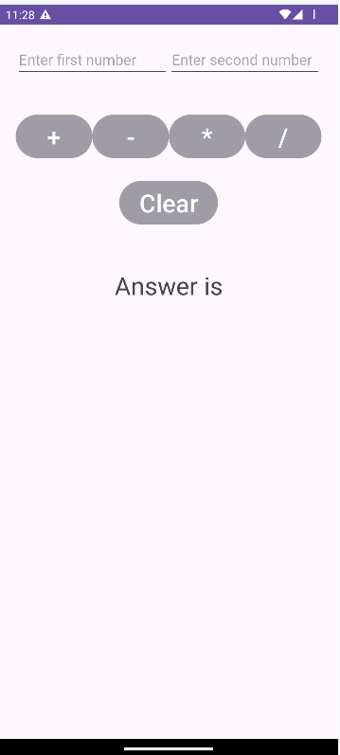

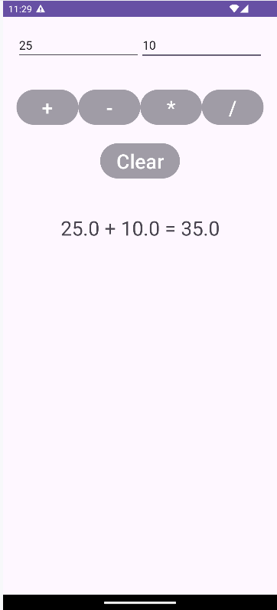

4. Write an application that draws basic graphical primitives on the screen
Program Code:
activity_main.xml:
Mainactivity.java:
package com.example.pgm4;
import android.app.Activity;
import android.graphics.Bitmap;
import android.graphics.Canvas;
import android.graphics.Color;
import android.graphics.Mesh;
import android.graphics.Paint;
import android.graphics.drawable.BitmapDrawable;
import android.os.Bundle;
import android.widget.ImageView;
public class MainActivity extends Activity {
@Override
public void onCreate(Bundle savedInstanceState)
{
super.onCreate(savedInstanceState);
setContentView(R.layout.activity_main);
//Creating a Bitmap
Bitmap bg = Bitmap.createBitmap(720, 1280, Bitmap.Config.ARGB_8888);
//Setting the Bitmap as background for the ImageView
ImageView i = (ImageView) findViewById(R.id.imageView);
i.setBackgroundDrawable(new BitmapDrawable(bg));
//Creating the Canvas Object
Canvas canvas = new Canvas(bg);
//Creating the Paint Object and set its color & TextSize
Paint paint = new Paint();
paint.setColor(Color.MAGENTA);
paint.setTextSize(50);
Paint paint1 = new Paint();
paint1.setColor(Color.YELLOW);
paint1.setTextSize(25);
//To draw a Rectangle
canvas.drawText("Rectangle", 420, 150, paint);
canvas.drawRect(400, 200, 650, 700, paint);
//To draw a Circle
canvas.drawText("Circle", 120, 150, paint);
canvas.drawCircle(200, 350, 150, paint);
//To draw a Oval
canvas.drawText("Oval", 130, 590, paint);
canvas.drawOval(50,600,350,1000,paint);
//To draw a Line
canvas.drawText("Line", 480, 800, paint);
canvas.drawLine(520, 850, 520, 1150, paint);
}
}

activity_main.xml:
<?xml version="1.0" encoding="utf-8"?>
<RelativeLayout xmlns:android="http://schemas.android.com/apk/res/android"
xmlns:app="http://schemas.android.com/apk/res-auto"
xmlns:tools="http://schemas.android.com/tools"
android:layout_width="match_parent"
android:layout_height="match_parent"
tools:context=".MainActivity">
<ImageView
android:layout_width="match_parent"
android:layout_height="match_parent"
android:id="@+id/imageView"
android:contentDescription="@string/todo" />
</RelativeLayout>

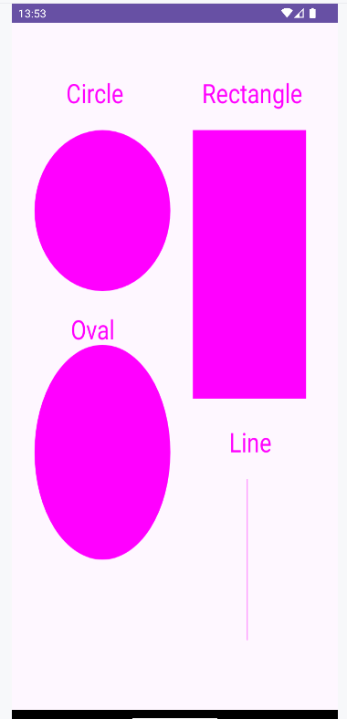

5. Develop an application that makes use of database
MainActivity.java:
package com.example.pgm5;
import android.app.Activity;
import android.app.AlertDialog.Builder;
import android.content.Context;
import android.database.Cursor;
import android.database.sqlite.SQLiteDatabase;
import android.os.Bundle;
import android.view.View;
import android.view.View.OnClickListener;
import android.widget.Button;
import android.widget.EditText;
public class MainActivity extends Activity implements OnClickListener {
EditText Rollno,Name,Marks;
Button Insert,Delete,Update,View,ViewAll,Clear;
SQLiteDatabase db;
/** Called when the activity is first created. */
@Override
protected void onCreate(Bundle savedInstanceState) {
super.onCreate(savedInstanceState);
setContentView(R.layout.activity_main);
Rollno=(EditText)findViewById(R.id.Rollno);
Name=(EditText)findViewById(R.id.Name);
Marks=(EditText)findViewById(R.id.Marks);
Insert=(Button)findViewById(R.id.Insert);
Delete=(Button)findViewById(R.id.Delete);
Update=(Button)findViewById(R.id.Update);
View=(Button)findViewById(R.id.View);
ViewAll=(Button)findViewById(R.id.ViewAll);
Clear=(Button)findViewById(R.id.Clear);
Insert.setOnClickListener(this);
Delete.setOnClickListener(this);
Update.setOnClickListener(this);
View.setOnClickListener(this);
ViewAll.setOnClickListener(this);
Clear.setOnClickListener(this);
// Creating database and table
db=openOrCreateDatabase("StudentDB", Context.MODE_PRIVATE, null);
db.execSQL("CREATE TABLE IF NOT EXISTS student(rollno VARCHAR,name VARCHAR,marks VARCHAR);");
}
@Override
public void onClick(View view){
// Inserting a record to the Student table
if(view==Insert)
{
// Checking for empty fields
if(Rollno.getText().toString().trim().length()==0||
Name.getText().toString().trim().length()==0||
Marks.getText().toString().trim().length()==0)
{
showMessage("Error", "Please enter all values");
return;
}
db.execSQL("INSERT INTO student VALUES('"+Rollno.getText()+"','"+Name.getText()+
"','"+Marks.getText()+"');");
showMessage("Success", "Record added");
clearText();
}
// Deleting a record from the Student table
if(view==Delete)
{
// Checking for empty roll number
if(Rollno.getText().toString().trim().length()==0)
{
showMessage("Error", "Please enter Rollno");
return;
}
Cursor c=db.rawQuery("SELECT * FROM student WHERE rollno='"+Rollno.getText()+"'", null);
if(c.moveToFirst())
{
db.execSQL("DELETE FROM student WHERE rollno='"+Rollno.getText()+"'");
showMessage("Success", "Record Deleted");
}
else
{
showMessage("Error", "Invalid Rollno");
}
clearText();
}
// Updating a record in the Student table
if(view==Update)
{
// Checking for empty roll number
if(Rollno.getText().toString().trim().length()==0)
{
showMessage("Error", "Please enter Rollno");
return;
}
Cursor c=db.rawQuery("SELECT * FROM student WHERE rollno='"+Rollno.getText()+"'", null);
if(c.moveToFirst()) {
db.execSQL("UPDATE student SET name='" + Name.getText() + "',marks='" +
Marks.getText() +
"' WHERE rollno='"+Rollno.getText()+"'");
showMessage("Success", "Record Modified");
}
else {
showMessage("Error", "Invalid Rollno");
}
clearText();
}
// Display a record from the Student table
if(view==View)
{
// Checking for empty roll number
if(Rollno.getText().toString().trim().length()==0)
{
showMessage("Error", "Please enter Rollno");
return;
}
Cursor c=db.rawQuery("SELECT * FROM student WHERE rollno='"+Rollno.getText()+"'", null);
if(c.moveToFirst())
{
Name.setText(c.getString(1));
Marks.setText(c.getString(2));
}
else
{
showMessage("Error", "Invalid Rollno");
clearText();
}
}
// Displaying all the records
if(view==ViewAll)
{
Cursor c=db.rawQuery("SELECT * FROM student", null);
if(c.getCount()==0)
{
showMessage("Error", "No records found");
return;
}
StringBuffer buffer=new StringBuffer();
while(c.moveToNext())
{
buffer.append("Rollno: "+c.getString(0)+"\n");
buffer.append("Name: "+c.getString(1)+"\n");
buffer.append("Marks: "+c.getString(2)+"\n\n");
}
showMessage("Student Details", buffer.toString());
}
if(view==Clear) {
Rollno.setText("");
Name.setText("");
Marks.setText("");
Rollno.requestFocus();
}
}
public void showMessage(String title,String message) {
Builder builder = new Builder(this);
builder.setCancelable(true);
builder.setTitle(title);
builder.setMessage(message);
builder.show();
}
public void clearText()
{
Rollno.setText("");
Name.setText("");
Marks.setText("");
Rollno.requestFocus();
}
}
activity_main.xml:
<?xml version="1.0" encoding="utf-8"?>
<RelativeLayout xmlns:android="http://schemas.android.com/apk/res/android"
xmlns:app="http://schemas.android.com/apk/res-auto"
xmlns:tools="http://schemas.android.com/tools"
android:layout_width="wrap_content"
android:layout_height="match_parent"
android:orientation="horizontal"
tools:context=".MainActivity">
<TextView
android:id="@+id/title"
android:layout_width="wrap_content"
android:layout_height="wrap_content"
android:layout_centerHorizontal="true"
android:layout_marginTop="10dp"
android:text="@string/student_details"
android:textColor="#FF5722"
android:textSize="35sp" />
<TextView
android:id="@+id/LabelRno"
android:layout_width="wrap_content"
android:layout_height="wrap_content"
android:layout_marginStart="20dp"
android:layout_marginTop="110dp"
android:text="Enter Rollno:"
android:textColor="#000000"
android:textSize="20sp" />
<TextView
android:id="@+id/LabelName"
android:layout_width="wrap_content"
android:layout_height="wrap_content"
android:layout_below="@+id/LabelRno"
android:layout_marginStart="20dp"
android:layout_marginTop="25dp"
android:text="Name:"
android:textColor="#000000"
android:textSize="20sp" />
<TextView
android:id="@+id/LabelMarks"
android:layout_width="wrap_content"
android:layout_height="wrap_content"
android:layout_below="@+id/LabelName"
android:layout_marginStart="20dp"
android:layout_marginTop="30dp"
android:text="Marks:"
android:textColor="#000000"
android:textSize="20sp" />
<EditText
android:id="@+id/Rollno"
android:layout_width="fill_parent"
android:layout_height="40dp"
android:layout_marginTop="100dp"
android:layout_toRightOf="@+id/LabelRno"
android:hint="Enter Roll No" />
<EditText
android:id="@+id/Name"
android:layout_width="fill_parent"
android:layout_height="60dp"
android:layout_below="@+id/Rollno"
android:layout_centerVertical="true"
android:layout_toRightOf="@+id/LabelName"
android:hint="Name" />
<EditText
android:id="@+id/Marks"
android:layout_width="fill_parent"
android:layout_height="60dp"
android:layout_below="@+id/Name"
android:layout_centerVertical="true"
android:layout_toRightOf="@+id/LabelMarks"
android:hint="Marks" />
<LinearLayout
android:layout_width="wrap_content"
android:layout_height="wrap_content"
android:orientation="horizontal"
android:layout_marginTop="270dp"
android:layout_centerHorizontal="true">
<Button
android:id="@+id/Insert"
android:layout_width="wrap_content"
android:layout_height="wrap_content"
android:text="Insert"
android:backgroundTint="#3F51B5"
android:textColor="@color/white"/>
<Button
android:id="@+id/Delete"
android:layout_width="wrap_content"
android:layout_height="wrap_content"
android:layout_marginLeft="15dp"
android:text="Delete"
android:backgroundTint="#3F51B5"
android:textColor="@color/white"/>
</LinearLayout>
<LinearLayout
android:layout_width="wrap_content"
android:layout_height="wrap_content"
android:orientation="horizontal"
android:layout_marginTop="320dp"
android:layout_centerHorizontal="true">
<Button
android:id="@+id/Update"
android:layout_width="wrap_content"
android:layout_height="wrap_content"
android:text="Update"
android:backgroundTint="#3F51B5"
android:textColor="@color/white"/>
<Button
android:id="@+id/View"
android:layout_width="wrap_content"
android:layout_height="wrap_content"
android:layout_marginLeft="15dp"
android:text="View"
android:backgroundTint="#3F51B5"
android:textColor="@color/white"/>
</LinearLayout>
<LinearLayout
android:layout_width="wrap_content"
android:layout_height="wrap_content"
android:orientation="horizontal"
android:layout_marginTop="370dp"
android:layout_centerHorizontal="true">
<Button
android:id="@+id/ViewAll"
android:layout_width="wrap_content"
android:layout_height="wrap_content"
android:text="ViewAll"
android:backgroundTint="#3F51B5"
android:textColor="@color/white"/>
<Button
android:id="@+id/Clear"
android:layout_width="wrap_content"
android:layout_height="wrap_content"
android:layout_marginLeft="15dp"
android:text="Reset"
android:backgroundTint="#3F51B5"
android:textColor="@color/white"/>
</LinearLayout>
</RelativeLayout>

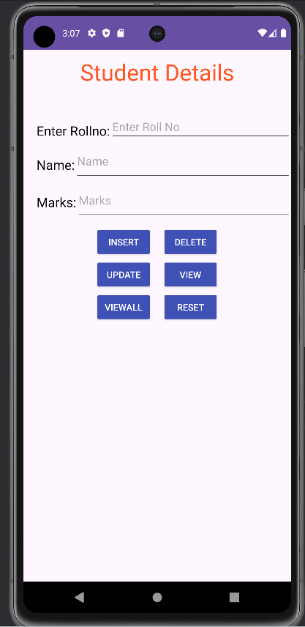

6. Implement an application that implements Multi threading

Program Code:
activity_main.xml:
<?xml version="1.0" encoding="utf-8"?>
<LinearLayout xmlns:android="http://schemas.android.com/apk/res/android"
xmlns:app="http://schemas.android.com/apk/res-auto"
xmlns:tools="http://schemas.android.com/tools"
android:layout_width="match_parent"
android:layout_height="match_parent"
tools:context=".MainActivity"
android:orientation="vertical"
android:id="@+id/info" >

<Button
android:id="@+id/button1"
android:layout_width="match_parent"
android:layout_height="wrap_content"
android:onClick="fetchData"
android:text="Start MULTITHREAD" />

<TextView
android:id="@+id/textView1"
android:layout_width="wrap_content"
android:layout_height="wrap_content"
android:text="Main thread" />
</LinearLayout>

MainActivity.java:
package com.example.pgm6;
import android.annotation.SuppressLint;
import android.app.Activity;
import android.os.Bundle;
import android.os.Handler;
import android.view.View;
import android.widget.TextView;
import androidx.appcompat.app.AppCompatActivity;
public class MainActivity extends AppCompatActivity {
private TextView tvOutput;
private static
final int t1 = 1;
private static final int t2 = 2;

private static final int t3 = 3;

@Override
protected void onCreate(Bundle savedInstanceState) {
super.onCreate(savedInstanceState);
setContentView(R.layout.activity_main);
tvOutput = (TextView) findViewById(R.id.textView1);
}

public void fetchData(View v) {
tvOutput.setText("Main thread");
thread1.start();
thread2.start();
thread3.start();
}

Thread thread1 = new Thread(new Runnable() {
@Override
public void run() {
for (int i = 0; i < 5; i++) {
try {
Thread.sleep(1000);
} catch (InterruptedException e) {
e.printStackTrace();
}
handler.sendEmptyMessage(t1);
}
}
});

//Thread2
Thread thread2 = new Thread(new Runnable() {
@Override
public void
run() {
for (int i = 0; i < 5; i++) {
try {
Thread.sleep(1000);
} catch (InterruptedException e) {
e.printStackTrace();
}
handler.sendEmptyMessage(t2);
}
}
});

//Thread3
Thread thread3 = new Thread(new Runnable() {
@Override
public void
run() {
for (int i = 0; i < 5; i++) {
try {
Thread.sleep(1000);
} catch (InterruptedException e) {
e.printStackTrace();
}
handler.sendEmptyMessage(t3);
}
}
});

//Handler
@SuppressLint("HandlerLeak")
Handler handler = new Handler() {
public void handleMessage(android.os.Message msg) {
if (msg.what == t1) {
tvOutput.append("\nRunning thread 1");
}
if (msg.what == t2) {
tvOutput.append("\nRunning thread 2");
}
if (msg.what == t3) {
tvOutput.append("\nRunning thread 3");
}
}
};
}

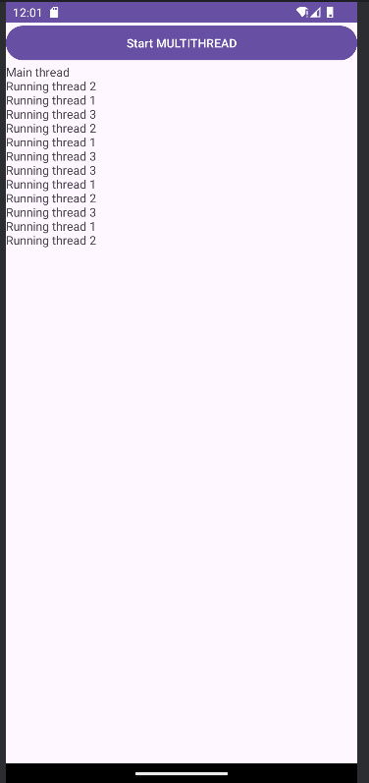

7. Develop a native application that uses GPS location information .

AndroidManifest.xml:

Add the necessary permissions to access location information:

<uses-permission android:name="android.permission.ACCESS_FINE_LOCATION" /> <uses-permission android:name="android.permission.ACCESS_COARSE_LOCATION" />

If you’re targeting Android 10 or higher, add the following for background location access:

<uses-permission android:name="android.permission.ACCESS_BACKGROUND_LOCATION" />

MainActivity.java:
package com.example.gpslocationapp;
import android.Manifest;
import androidx.annotation.NonNull;
import androidx.appcompat.app.AppCompatActivity;
import android.content.pm.PackageManager;
import android.location.Location;
import android.location.LocationListener;
import android.location.LocationManager;
import android.os.Bundle;
import android.widget.TextView;
import android.widget.Toast;
import androidx.core.app.ActivityCompat;
public class MainActivity extends AppCompatActivity {
private static final int LOCATION_PERMISSION_REQUEST_CODE = 1;
private LocationManager locationManager;
private LocationListener locationListener;
private TextView locationTextView;
@Override
protected void onCreate(Bundle savedInstanceState) {
super.onCreate(savedInstanceState);
setContentView(R.layout.activity_main);
locationTextView = findViewById(R.id.locationTextView);
locationManager = (LocationManager) getSystemService(LOCATION_SERVICE);
locationListener = new LocationListener() {
@Override
public void onLocationChanged(@NonNull Location location) {
double latitude = location.getLatitude();
double longitude = location.getLongitude();
locationTextView.setText("Latitude: " + latitude + "\nLongitude: " + longitude);
}
};
requestLocationPermission();
}
private void requestLocationPermission() {
if (ActivityCompat.checkSelfPermission(this, Manifest.permission.ACCESS_FINE_LOCATION) != PackageManager.PERMISSION_GRANTED) {
ActivityCompat.requestPermissions(this,
new String[]{Manifest.permission.ACCESS_FINE_LOCATION}, LOCATION_PERMISSION_REQUEST_CODE);
} else {
startListening();
}
}
private void startListening() {
if (ActivityCompat.checkSelfPermission(this, Manifest.permission.ACCESS_FINE_LOCATION) == PackageManager.PERMISSION_GRANTED) {
locationManager.requestLocationUpdates(LocationManager.GPS_PROVIDER, 5000, 10, locationListener);
}
}
@Override
public void onRequestPermissionsResult(int requestCode, @NonNull String[] permissions, @NonNull int[] grantResults) {
super.onRequestPermissionsResult(requestCode, permissions, grantResults);
if (requestCode == LOCATION_PERMISSION_REQUEST_CODE) {
if (grantResults.length > 0 && grantResults[0] == PackageManager.PERMISSION_GRANTED) {
startListening();
} else {
Toast.makeText(this, "Permission denied", Toast.LENGTH_SHORT).show();
}
}
}
}

activity_main.xml:
<?xml version="1.0" encoding="utf-8"?>
<LinearLayout xmlns:android="http://schemas.android.com/apk/res/android"
android:layout_width="match_parent"
android:layout_height="match_parent"
android:orientation="vertical"
android:gravity="center"
android:padding="16dp">
<TextView
android:id="@+id/locationTextView"
android:layout_width="wrap_content"
android:layout_height="wrap_content"
android:text="Fetching location..."
android:textSize="18sp"
android:textAlignment="center" />
</LinearLayout>

To run the application:
Connect a physical device or use an emulator with GPS enabled.
Grant location permission when prompted.
The application will display the latitude and longitude in real-time.
Output:
A permission dialog will appear asking for access to the device's location.
If Permission Granted, the app will display latitude and longitude of the current location.

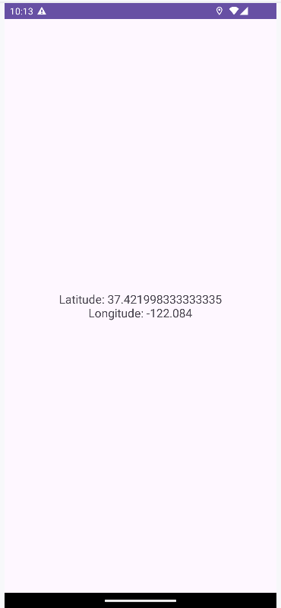

If Permission is Denied A toast will appear : “Permission Denied”
You can manually set the GPS location for the emulator:
- Open the AVD emulator.
- Go to Extended Controls (three dots in the toolbar).
- Navigate to the Location tab.
- Enter custom latitude and longitude values and click Send.
Example:
  - Latitude: 51.5074
  - Longitude: -0.1278 (London, UK)
- The app will display the updated location based on these values.

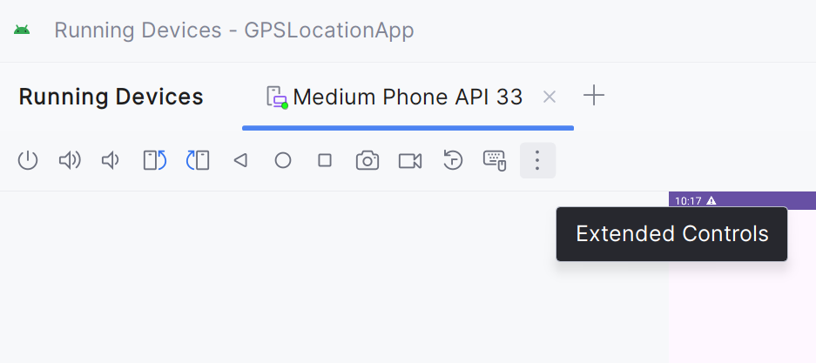

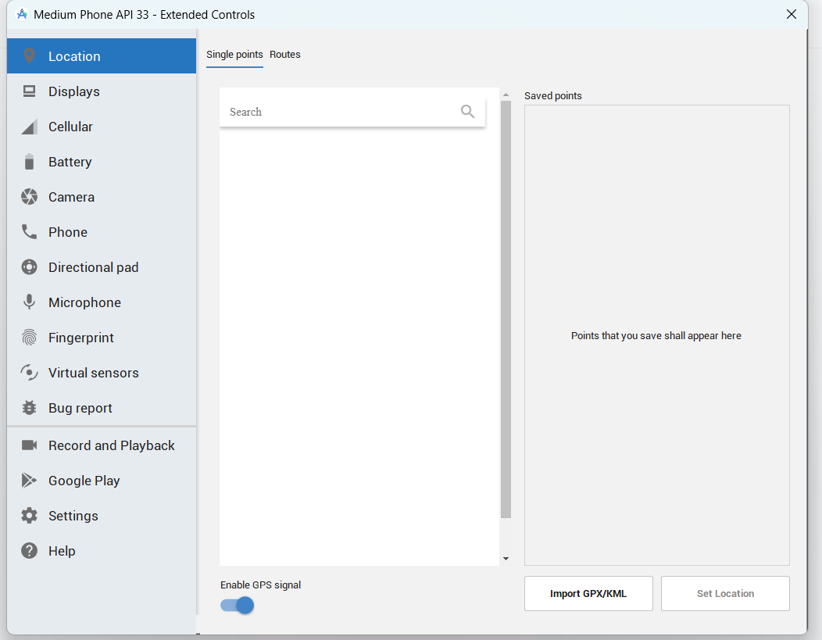

8.Implement an application that writes data to the SD Card.
MainActivity.java:
package com.example.pgm8;

import androidx.appcompat.app.AppCompatActivity;
import android.os.Bundle;
import android.os.Environment;
import android.view.View;
import android.widget.Button;
import android.widget.EditText;
import android.widget.TextView;
import android.widget.Toast;

import java.io.BufferedReader;
import java.io.DataInputStream;
import java.io.File;
import java.io.FileInputStream;
import java.io.FileOutputStream;
import java.io.IOException;
import java.io.InputStreamReader;

public class MainActivity extends AppCompatActivity {
EditText inputText;
TextView response;
Button saveButton,readButton;
private String filename = "SampleFile.txt";
private String filepath= "MyFileStorage";
File myExternalFile;
String myData= "";
Button cls;
@Override
protected void onCreate(Bundle savedInstanceState) {
super.onCreate(savedInstanceState);
setContentView(R.layout.activity_main);
inputText= (EditText) findViewById(R.id.myInputText);
response = (TextView) findViewById(R.id.response);

saveButton=
(Button) findViewById(R.id.saveExternalStorage);
saveButton.setOnClickListener(new View.OnClickListener() {
@Override
public void onClick(View v) {
try {
FileOutputStream fos = new FileOutputStream(myExternalFile); //Used for writing data to a file
fos.write(inputText.getText().toString().getBytes()); //It is used to write the specified byte to the file output stream
fos.close();
} catch (IOException e) {
e.printStackTrace();
}
inputText.setText("");
response.setText("SampleFile.txt saved to External Storage...");
}
});
readButton= (Button) findViewById(R.id.getExternalStorage);
readButton.setOnClickListener(new View.OnClickListener() {
@Override
public void onClick(View v) {
try {
FileInputStream fis = new FileInputStream(myExternalFile); //It is used for reading byte-oriented data
DataInputStream in = new DataInputStream(fis); //Java DataInputStream class allows an application to read primitive data from the input stream
BufferedReader br =
new BufferedReader(new InputStreamReader(in)); //used to read the text from a character-based input stream
String strLine;
while ((strLine = br.readLine()) != null) { //used for reading a line of text.
myData= myData+ strLine;
}
in.close();
} catch (IOException e) {
e.printStackTrace();
}
inputText.setText(myData);
response.setText("SampleFile.txt data retrieved from Internal Storage...");
}
});
if (!isExternalStorageAvailable() || isExternalStorageReadOnly()) {
saveButton.setEnabled(false);
}
else {
myExternalFile= new File(getExternalFilesDir(filepath), filename);
}
}
private static boolean isExternalStorageReadOnly() {
String extStorageState = Environment.getExternalStorageState();
if(Environment.MEDIA_MOUNTED_READ_ONLY.equals(extStorageState)) {
return true;
}
return false;
}
private static boolean isExternalStorageAvailable() {
String extStorageState = Environment.getExternalStorageState();
if(Environment.MEDIA_MOUNTED.equals(extStorageState)) {
return true;
}
return false;
}
}
activity_main.xml:
<?xml version="1.0" encoding="utf-8"?>
<LinearLayout xmlns:android="http://schemas.android.com/apk/res/android"
xmlns:app="http://schemas.android.com/apk/res-auto"
xmlns:tools="http://schemas.android.com/tools"
android:layout_width="match_parent"
android:layout_height="match_parent"
android:orientation="vertical"
tools:context=".MainActivity">

<TextView android:layout_width="fill_parent"
android:layout_height="wrap_content"
android:text="Reading and Writing to External Storage"
android:textSize="24sp"/>

<EditText android:id="@+id/myInputText"
android:layout_width="match_parent"
android:layout_height="wrap_content"
android:ems="10" android:lines="5"
android:minLines="3" android:gravity="top|left"
android:inputType="textMultiLine">
<requestFocus/>
</EditText>
<LinearLayout
android:layout_width="match_parent"
android:layout_height="wrap_content"
android:orientation="horizontal"
android:weightSum="1.0"
android:layout_marginTop="20dp">

<Button android:id="@+id/saveExternalStorage"
android:layout_width="match_parent"
android:layout_height="wrap_content"
android:text="WRITE"
android:layout_weight="0.5"/>

<Button android:id="@+id/getExternalStorage"
android:layout_width="match_parent"
android:layout_height="wrap_content"
android:layout_weight="0.5"
android:text="READ" />
</LinearLayout>
<TextView android:id="@+id/response"
android:layout_width="wrap_content"
android:layout_height="wrap_content" android:padding="5dp"
android:text=""
android:textAppearance="?android:attr/textAppearanceMedium" />
</LinearLayout>

AndroidManifest.xml:
Add the below lines of code in manifest file above <application> tag

<uses-permission android:name="android.permission.WRITE_EXTERNAL_STORAGE"
android:maxSdkVersion="32" />
<uses-permission android:name="android.permission.READ_EXTERNAL_STORAGE"
android:maxSdkVersion="32" />

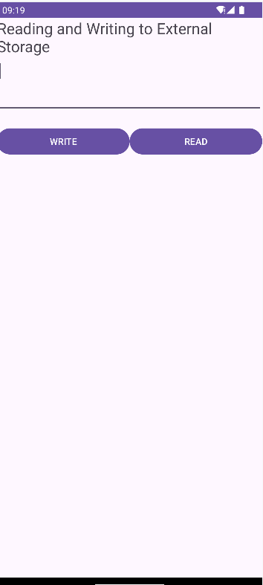

9.Implement an application that creates an alert upon receiving a message
MainActivity.java:
package com.example.program9;
import android.app.Activity;
import android.content.Intent;
import android.os.Bundle;
import android.view.View;
import android.widget.Button;
import android.widget.EditText;
import android.widget.Toast;

public class MainActivity extends Activity {
private Button BTN;
private EditText email;

@Override
protected void onCreate(Bundle savedInstanceState) {
super.onCreate(savedInstanceState);
setContentView(R.layout.activity_main);
BTN = (Button) findViewById(R.id.btn);
email = (EditText) findViewById(R.id.emailInput);
BTN.setOnClickListener(new View.OnClickListener() {
@Override
public void onClick(View v) {
String val = email.getText().toString();
if (val == null || val.length() <= 0) {
Toast.makeText(getApplicationContext(),
"Please Enter the email", Toast.LENGTH_LONG).show();
} else if (val.equals("xyz@gmail.com")) {
Intent intent = new Intent(getApplicationContext(),
SecondActivity.class);
startActivity(intent);
Toast.makeText(getApplicationContext(),
"Login Success", Toast.LENGTH_LONG).show();
} else {
Toast.makeText(getApplicationContext(),
"Please Enter valid email", Toast.LENGTH_LONG)
.show();
}

}
});
}
}

activity_main.xml:
<?xml version="1.0" encoding="utf-8"?>
<LinearLayout xmlns:android="http://schemas.android.com/apk/res/android"
xmlns:app="http://schemas.android.com/apk/res-auto"
xmlns:tools="http://schemas.android.com/tools"
android:layout_width="match_parent"
android:layout_height="match_parent"
android:orientation="vertical"
tools:context=".MainActivity">

<TextView
android:id="@+id/textView"
android:layout_width="match_parent"
android:layout_height="wrap_content"
android:layout_marginTop="250dp"
android:layout_marginLeft="15dp"
android:fontFamily="sans-serif-black"
android:gravity="left"
android:text="Enter valid email address"
android:textColor="#3F51B5"
android:textSize="18sp" />

<EditText
android:id="@+id/emailInput"
android:layout_width="match_parent"
android:layout_height="wrap_content"
android:singleLine="true"
android:layout_marginLeft="15dp"
android:layout_marginRight="15dp"
android:textSize="30sp" />

<Button
android:id="@+id/btn"
android:layout_width="wrap_content"
android:layout_height="wrap_content"
android:layout_margin="30dp"
android:layout_gravity="center"
android:text="Login"
android:textSize="30sp"/>

</LinearLayout>

AndroidManifest.xml:
Add the following line in Manifest file:
<uses-permission android:name="android.permission.POST_NOTIFICATIONS" />

Create and empty view activity: name it as SecondActivity.java
package com.example.program9;
import android.app.Activity;
import android.os.Bundle;
public class SecondActivity extends Activity {
@Override
protected void onCreate(Bundle savedInstanceState) {
super.onCreate(savedInstanceState);
}
}

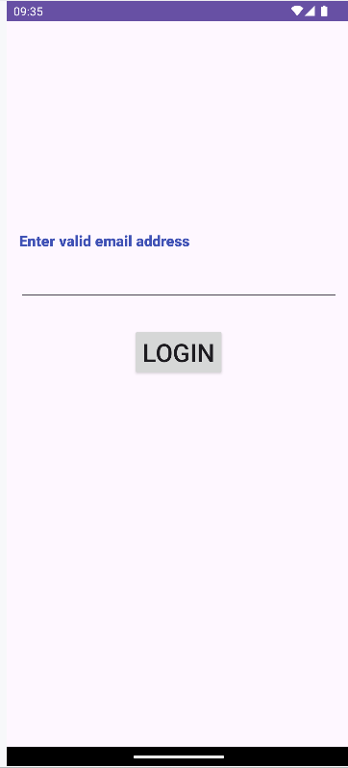

10. Write a mobile application that creates alarm clock
MainActivity.java:

package com.example.alarmclockpgm;

import android.app.AlarmManager;
import android.app.PendingIntent;
import android.content.Intent;
import android.os.Bundle;
import android.view.View;
import android.widget.TimePicker;
import android.widget.Toast;
import android.widget.ToggleButton;

import androidx.appcompat.app.AppCompatActivity;

import java.util.Calendar;

public class MainActivity extends AppCompatActivity
{
TimePicker alarmTimePicker;
PendingIntent pendingIntent;
AlarmManager alarmManager;
@Override
protected void onCreate(Bundle savedInstanceState)
{
super.onCreate(savedInstanceState);
setContentView(R.layout.activity_main);
alarmTimePicker= (TimePicker) findViewById(R.id.timePicker);
alarmManager= (AlarmManager) getSystemService(ALARM_SERVICE);
}
public void OnToggleClicked(View view)
{
long time;
if (((ToggleButton) view).isChecked())
{
Toast.makeText(MainActivity.this, "ALARM ON", Toast.LENGTH_SHORT).show();
Calendar calendar = Calendar.getInstance();
calendar.set(Calendar.HOUR_OF_DAY, alarmTimePicker.getCurrentHour());
calendar.set(Calendar.MINUTE, alarmTimePicker.getCurrentMinute());
Intent intent = new Intent(this, AlarmReceiver.class);
pendingIntent= PendingIntent.getBroadcast(this, 0, intent, PendingIntent.FLAG_IMMUTABLE);
time=(calendar.getTimeInMillis()-(calendar.getTimeInMillis() % 60000));
if(System.currentTimeMillis() > time)
{
if (calendar.AM_PM == 0)
time = time + (1000*60*60*12);
else
time = time + (1000*60*60*24);
}
alarmManager.setRepeating(AlarmManager.RTC_WAKEUP, time, 10000, pendingIntent);
}
else
{
alarmManager.cancel(pendingIntent);

Toast.makeText(MainActivity.this, "ALARM OFF", Toast.LENGTH_SHORT).show();
}
}
}

AlarmReceiver.java:
package com.example.alarmclockpgm;

import android.content.BroadcastReceiver;
import android.content.Context;
import android.content.Intent;
import android.media.Ringtone;
import android.media.RingtoneManager;
import android.net.Uri;
import android.widget.Toast;
public class AlarmReceiver extends BroadcastReceiver
{
@Override
public void onReceive(Context context, Intent intent)
{
Toast.makeText(context, "Alarm! Wake up! Wake up!", Toast.LENGTH_LONG).show();
Uri alarmUri = RingtoneManager.getDefaultUri(RingtoneManager.TYPE_ALARM);
if (alarmUri == null)
{
alarmUri = RingtoneManager.getDefaultUri(RingtoneManager.TYPE_NOTIFICATION);
}
Ringtone ringtone = RingtoneManager.getRingtone(context, alarmUri);
ringtone.play();
}
}

AndroidManifest.xml:

Add the below lines of code:
<uses-permission android:name="android.permission.VIBRATE"/>

Add the below code under <application>tag
<receiver android:name=".AlarmReceiver" >
</receiver>
activity_main.xml code:

<?xml version="1.0" encoding="utf-8"?>
<LinearLayout xmlns:android="http://schemas.android.com/apk/res/android"
android:layout_width="match_parent"
android:layout_height="match_parent"
android:orientation="vertical">

<TimePicker
android:id="@+id/timePicker"
android:layout_width="wrap_content"
android:layout_height="wrap_content"
android:layout_gravity="center"
android:headerBackground="@color/design_default_color_secondary_variant" />
<ToggleButton
android:id="@+id/toggleButton"
android:layout_width="wrap_content"
android:layout_height="wrap_content"
android:layout_gravity="center"
android:layout_margin="20dp"
android:checked="false"
android:onClick="OnToggleClicked" />
</LinearLayout>
